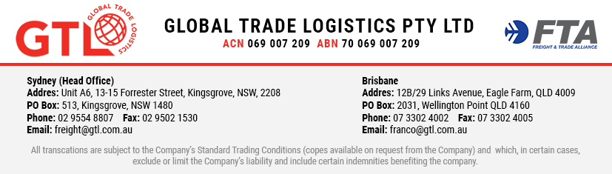

AUTHORISATION AND ACKNOWLEDGEMENT OF TERMS AND CONDITIONS

- ACCEPTANCE OF TERMS & CONDITIONS
  - The customer named below (Customer) agrees that all services provided by GLOBAL TRADE LOGISTICS PTY LTD (ABN 70 069 007 209), its nominees and/or its agents (the Company) are subject to the Company's Standard Terms and Conditions, as amended, varied or replaced from time to time (T&C).
  - The Customer acknowledges receipt of the T&C and agrees that it accepts to be bound by the terms of this Authority and the T&C.

TERM OF AUTHORITY
  - This Authority will apply from the date of this Authority until terminated by either party.
  - This Authority is terminated by giving the other party written notice of termination.

AUTHORITY
  - The Customer authorises the Company to:
    - act as the Customer's agent and customs broker;
    - quote the Customer's Australian Business Number stated below as may be required to perform services on behalf of the Customer;
    - act on the Customer's behalf for all purposes contemplated by any Customs-related law (as defined in the Customs Act 1901) and for any purpose required to assist with import, export, carriage, storage, treatment and delivery of goods; and
    - act on behalf of the Customer do all things requested by any government authority, department or body, related to the clearance, carriage and delivery of the goods.

AUTHORITY OF SIGNATORY
The authorised signatory whose name is set out below (Authorised Signatory) warrants that it either is the Customer or has the express written authority of the Customer to enter into this Authority on the Customer's behalf.

LIABILITY
If the Authorised Signatory is not the Customer or does not have the authority to enter into this Authority on the Customer's behalf, the Authorised Signatory agrees and acknowledges that it will be taken to have entered into this Authority on its own behalf and will be treated as the Customer under the T&C.

Signature of Authorised Signatory |  | Date
Full name of Authorised Signatory |  | Position of Authorised Signatory
Customer Name |  | Customer's Australian Business Number (ABN)

